TASK 14: Design a simple microservices-based system by splitting a monolithic application into at least two independent services. Apply microservices design principles such as loose coupling, single responsibility, and independent deployment.

Step 1: Google Chrome / Edge
1.Open Chrome – https://start.spring.io
2. Project – Maven
3.Language – Java
4. Spring Boot Version – Leave Default
5.Group_Name – com.factorial
6.Artifact – demo
7.Package Name – com.factorial.demo
8. Packaging – Jar, Configuration – Properties, Java – 17
Step 2: Add Dependencies
1.Spring Web
Step 3: click Generate
# Zip file will be Downloaded
# open File Manager Extract the Zip File
Step 4: Open ECLIPSE
- Go to File – Click Import – Import the file
- Open the folder
  - – src/main/java
  - Create CLASS – FactController
Code:
import org.springframework.web.bind.annotation.GetMapping;
import org.springframework.web.bind.annotation.RequestParam;
import org.springframework.web.bind.annotation.RestController;
@RestController
public class FactController {
@GetMapping("/fact")
public long calculateFact(@RequestParam int num) {
long fact = 1;

for(int i = 1; i <= num; i++) {
fact = fact * i;
}
return fact;
}
}
Step 5: Open Src/main/resources
1.Open Application.properties
Add this:
spring.application.name=factorial
server.port=8084
# Save It – ctrl+s
Step 6: Open Src/main/java
1.open - FactorialApplication.java
2.Right click – Open SpringBoot

Step 7: Open Chrome Url /Edge Url
Type - http://localhost:8084/fact?num=5
Output:
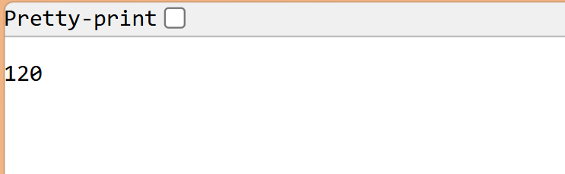

FOR Square Root:
Step 1: Google Chrome / Edge
1.Open Chrome – https://start.spring.io
2. Project – Maven
3.Language – Java
4. Spring Boot Version – Leave Default
5.Group_Name – com.Squareroot
6.Artifact – demo
7.Package Name – com.squarerootdemo
8. Packaging – Jar, Configuration – Properties, Java – 17
Step 2: Add Dependencies
1.Spring Web
Step 3: click Generate
# Zip file will be Downloaded
# open File Manager Extract the Zip File
Step 4: Open ECLIPSE
- Go to File – Click Import – Import the file
- Open the folder
  - – src/main/java
  - Create CLASS – SqrtController
Code:
import org.springframework.web.bind.annotation.GetMapping;
import org.springframework.web.bind.annotation.RequestParam;
import org.springframework.web.bind.annotation.RestController;
@RestController
public class SqrtController {
@GetMapping("/sqrt")
public double calculateSqrt(@RequestParam int num)
{
return Math.sqrt(num);
}
}
Step 5: Open Src/main/resources
1.Open Application.properties
Add this:
spring.application.name=factorial
server.port=8080
# Save It – ctrl+s
Step 6: Open Src/main/java
1.open - FactorialApplication.java
2.Right click – Open SpringBoot

Step 7: Open Chrome Url /Edge Url
Type - http://localhost:8080/sqrt?num=5

